**Brooklyn torah gazette**

**For parshas shemos 5782**

Volume 6, Issue 14 (Whole Number 269) 21 Teves 5782/ December 25, 2021

**Printed L’illuy nishmas Nechama bas R’ Noach, a”h**

For a free subscription, please forward your request to [***keren18@juno.com***](mailto:keren18@juno.com)

**Rav Avigdor Miller’s “Serious” Mistake**

**By Daniel Keren**

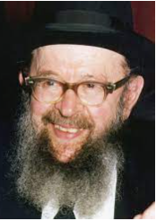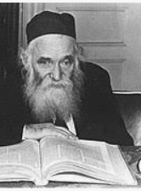

**Rabbi Avigdor Miller and Rabbi Aharon Kotler**

Recently Rabbi Eliyahu Brog, shlita, the grandson of Rav Avigdor Miller, zt”l, and mora d’asra of Congregation Bais Yisroel of Rugby on Ocean Parkway that was founded by his grandfather spoke of the time his grandfather once made a “serious” mistake back in the early 1950’s a few years after taking over as the rabbi of the Young Israel of Rugby in East Flatbush.

He had attended a meeting of Brooklyn rabbis and one of the participants got up to speak about what he perceived as a major threat to American Jewry in general and to young Orthodox Jewish men in particular. This rabbi was speaking of the danger of “Kotlerism”, a movement created by Rabbi Aharon Kotler, zt”l, who had just founded the Beth Medrash Govoha yeshiva in the Lakewood Township, New Jersey in 1943 with just 15 students.

What distinguished Beth Medrash Govoha from other American yeshivas was Rabbi Kotler’s enthusiastic emphasis that young men should dive into the Yam HaTorah and study Torah lishmo, the sake of trying to understand the complexities and beauties of the Torah for the sake of Hashem and not for any ulterior purposes such as trying to gain smicha (rabbinical ordination) for parnassa (livelihood) or even to be a religious teacher in a yeshiva or Jewish day school.

However according to the rabbi at the Brooklyn conference which Rabbi Miller attended almost 70 years ago, this Torah concept then uncommon in America constituted the dangerous cult of Kotlerism [almost on par with Communism, atheism, secular Zionism and other isms] that was a terrible threat to the future of American Jewish youth. Instead, young Jewish men should be encouraged to attend universities and thereby qualify for good professions in order to be able to comfortably support their families.

Unable to continue listening to the terrible lashon hora being unleashed against Rav Kotler, a great gadol b’Torah by this arrogant and ignorant American-born modern rabbi, Rabbi Miller stood up from his seat and approached the podium and began forcibly pushing the offending anti-Kotlerism rabbi away, while hushing him to be silent.

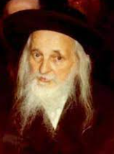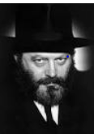

**The Satmar Rebbe and the Lubavitcher Rebbe**

Afterwards that night, Rabbi Miller began to think that perhaps he was wrong to of have embarrassed a fellow Yid, even if he was repulsed by the awful lashon hora recited by the victim of his defense of Rav Kotler. So he decided to get the opinions of two gedolei Torah who lived in Brooklyn – Rabbi Yoel Teitelbaum, zt”l, the Satmar Rebbe and Rabbi Menachem Mendel Schneerson, zt”l,

In those days in the early 1950s, the Orthodox Jewish community was quite small especially compared to the dynamic rapidly growing community of today. Both the Satmar and Lubavitch Chassidic communities were also much smaller than today. It wasn’t that difficult for Rabbi Miller to call the offices of both the Satmar and Lubavitcher Rebbe and be quickly connected to the great Torah leaders.

In each of his conversations with the respective Chassidic rebbes, Rav Miller repeated what had happened the day before. And he added that the previous night he had called the rabbi that he had embarrassed at the Brooklyn rabbinical conference and asked him for mechila (forgiveness) for having humiliated him in front of all the other rabbis at the gathering.)

After relaying in separate phone calls to the Satmar and Lubavitcher Rebbes what he had done, Rabbi Miller asked whether he was wrong for having rushed to defend the honor of Rav Kotler. He later told his grandson almost a half century later that both the Chassidic leaders had sharply criticized him for his “serious” mistake. Why they asked him without knowing what the other Rebbe had answered did he degrade the honor of the Torah by asking that other “rabbi” for his worthless “mechilah.”

*Reprinted from this week’s edition of The Jewish Connection.*

**Funny, He Didn’t**

**“Look” Jewish**

The following appeared in last week’s Likutei Shmuel edited by Sam. Eiskkovits.

Santa is in Macy’s department store, when a small girl sits on his lap. Santa says:

"Ho Ho Ho. What’s your name, little girl, and what do you want for Xmas?"

“Patty, and I’d like a Beanie Baby, please.”

“OK. Now, take a gift from my toy sack."

Next, Santa asks a little boy: "What’s your name and what do you want for Xmas?"

"Peter. I want a laser baseball."

“Fine. Take a present from my toy sack."

Another boy steps up. "What’s your name and what do want for Xmas?"

"Irving and I'm Jewish. I’m not allowed to ask Santa for anything."

Santa pointed to his toy sack and whispers, "Nem tzvay" [take two].

Submitted by Marnie MacCauley.

**Rabbi Berel Wein**

**On Parshas Shemos**

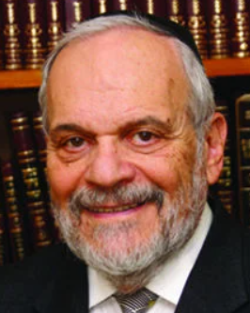

Nothing human is ever permanent. Perhaps the only exception to this rule is human nature itself, which, seemingly, has never changed from the days of the Garden of Eden until today. So, we should not be surprised by the narrative of the Torah in this week's portion.

The Jewish people have been in Egypt for centuries. They have lived off the fat of the Land in Goshen. They were highly respected, apparently affluent, and thought themselves to be secure in their land of exile. The memory of their leader Joseph, who was the savior of Egypt, still lingered in their minds, and also in the minds of the general Egyptian public.

But Joseph was gone already for centuries, and as the Jewish people multiplied and continued to succeed within the Egyptian population its government, through the Pharaoh, began to look askance at them. They were no longer fellow citizens or loyal subjects, but, rather, were now seen as a dangerous and insidious minority that, because of its birthright and success, could endanger Egyptian society.

There now arose a new era, different from the centuries that preceded it. When the Talmud teaches us that there arose a new Pharaoh, one of the opinions is that a new attitude towards the Jews, one of suspicion and jealousy was apparent. The Jews were now seen as being an internal enemy, a disloyal section of society, an existential threat to the pharaohs of Egypt specifically, and to Egyptian society generally.

**Unable to Detect the Change in Attitude**

The Midrash seems to indicate that the Jews were not sensitive enough to realize how dangerous the change of attitude towards them was, in the general Egyptian society. When Pharaoh requested volunteers to come forth to help him in his great building projects, we are taught that the Jews came in masse to help build those symbols of might and wealth of ancient Egypt. The Pharaoh then, and undoubtedly with the help and acquiescence of much of Egyptian society, removed from the Jews their voluntary status, until suddenly they found themselves slaves and servants of Egypt, and no longer merely sojourners in the country.

And there were Jews who were willing to cooperate with the governmental authorities in policing the Jewish slave society. Eventually, these Jews also found themselves to be the victims of the Pharaoh and his cruel decree. It is no wonder that so many Jews – according to various opinions of the rabbis of Talmud and Midrash – never were able to extricate themselves from Egypt, even when Moshe successfully led the Jewish people out of Egyptian bondage, and out of Egypt itself.

**A Pattern that Will Apply to All Later Exiles**

There is, undoubtedly, a pattern that the Torah introduces which will apply to all later exiles of the Jewish people throughout the world. The end of an era always occurs suddenly and unexpectedly, illogically, and shockingly. The story of the end European Jewry that occurred almost a century ago is a sobering reminder of this pattern of exile. Jews should be wise enough to realize that ignoring the lessons of history is a truly fatal course in life.

*Reprinted from this week’s website of rabbiwein.com*

# Rav Avigdor Miller

# On Saying No to Divorce



**QUESTION: Should a woman stay with her husband no matter what?**

**ANSWER:** Yes! If he works. He has to work. If he doesn’t work, it’s a very big problem. He has to work to make a living. It’s his duty to work. As it says openly in the kesubah, “אנא אפלח – I’m going to work and support you.” That’s his job to do. He has to be a shomer mitzvos too. (TAPE # E-234)

**QUESTION: But should a woman have to suffer from a husband who’s a boor?**

**ANSWER:** Once you’re married, you have to make the best of it. Maybe you’re the one who is to blame more than your husband. Whatever it is, look before you leap. Once you leapt, then stay where you are. And live your whole life satisfactorily. You get s’char; you’ll get reward.

The idea of always being dissatisfied is a tragedy; the world today is in motion, in disturbance, and so many divorces are wrong. Every divorce is a tragedy; it’s a Churban Bais Hamikdosh to ruin a Jewish home.

And so no matter whom you marry, as long as he’s a shomer mitzvos and he’s working to support the family, then you should make it your business to be loyal to him and stay together. You’ll marry off your grandchildren together; you’ll have nachas.

Don’t make any fuss; and don’t say, “I want to leave him” or “I should have had a better husband,” or “a more affectionate husband,” or “a bigger lamdan;” don’t look for faults in him. The one you married, that’s the one you should stay with.  
TAPE # E-234

*Reprinted from the December 12, 2021 email of Toras Avigdor (Tape 553)*

**Thoughts that Count for**

**This Week’s Parsha**

*And these are the names of the Children of Israel who were coming to Egypt with Yaakov; each man and his household came.* (Exod. 1:1)

To mention "Yaakov" and "each man and his household" seems superfluous. When a man marries and raises a family, he is considered the head of the household, the one turned to for advice and guidance. As he ages and his children mature, the children often take over running the family. Despite the fact that Yaakov was very old and his children were all grown, Yaakov still led the household, with his children following. *(Ba'al Haturim)*

*Pharoah commanded all his people saying, "Every son that is born cast him into the river, and every daughter you shall sustain.*" (Exodus 1:22)

The Hebrew word for "you shall sustain" is "techayun," which means, "you shall be the source of life." Pharoah told the Egyptians to take in the Jewish daughters and totally assimilate them into the Egyptian way of life. Pharoah ordered a physical extermination of the boys, and a spiritual extermination of the girls. Both decrees are written in the same verse to show that they are equivalent in their harshness. *(Likutei Sichot)*

*Reprinted from Reprinted from the 5757/1996 Shemos edition of L’Chaim Weekly. Excerpted from* *Vedibarta Bam by Rabbi Moshe Bogomilsky*

**The Challenge of Not**

**Sacrificing One’s Spiritual Service in Pursuit of a Livelihood**

**From the Talks of the Lubavitcher Rebbe**

**Rabbi Menachem Mendel Schneerson, Zt”l**

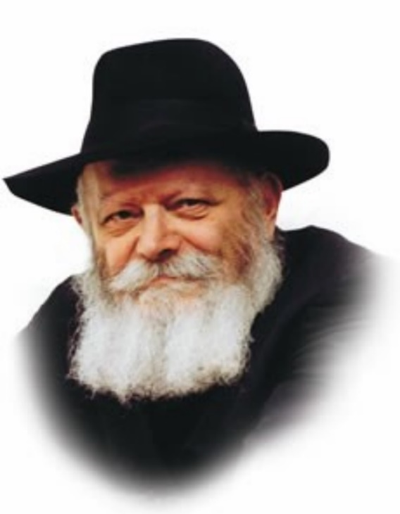

For the Jew, true vitality is derived not from his physical existence but from his spiritual life. Thus, when the Torah relates in this week's Torah portion, Shemot, that the Egyptians "embittered their lives with hard labor" we understand that this refers to the Jews' spiritual existence and not merely their physical condition.

How did strenuous physical labor affect the Jews spirituality?

"Harsh labor" is any exertion that has no aim or that brings no tangible advantage. Such labor has no boundaries; it is never finished and never attains its objective.

When a Jew conducts his business affairs according to the Torah's dictates, his efforts are measured and invested only in labors that are beneficial. He knows that a certain amount of time must be devoted to praying and learning Torah; not all of his energies go into the pursuit of a livelihood.

"You shall eat the labor of your hands" -- only his hands, not his head, are involved in his work. The Jew does only as much as is required; his heart and mind are reserved for higher pursuits. The lion's share of his energy is devoted to the service of G-d.

When a Jew approaches his business affairs in this manner, G-d sends him his livelihood in abundance and blesses him with all that he needs.

However, when a person's attitude toward working is not in accordance with the Torah, all of his thoughts become caught up in his livelihood. All he can think of night and day is how to succeed and obtain greater profits. The person can never relax; he cannot sleep in peace.

Business becomes his sole preoccupation; he is always "at work." This is the meaning of "harsh labor": an effort that has no end and no clearly defined measure. In truth, he can never succeed with such an approach, for only G-d can grant us our livelihood.

G-d created the world in such a way that there is a time and a place for everything. There is a limit to what we are expected to do, and all of our efforts are rewarded commensurately. The Egyptians, however, enslaved the Jewish people "with harsh labor."

Only the G-dly soul is able to toil "without measure and without benefit." The soul is limitless. Because it is connected to G-d, its powers are likewise infinite. The service of the soul is above all constraints. It does not serve G-d in order to receive reward, but purely for the sake of heaven.

When the Egyptians forced the Jews to engage in "hard labor," they took these higher qualities of the soul and perverted them by applying them to the physical realm. The Jews' labor in Egypt was thus "without measure and without end." For this reason, the Jewish people's lives were embittered -- their true lives, i.e., their spiritual existence.

*Reprinted from Reprinted from the 5757/1996 Shemos edition of L’Chaim Weekly, adapted from Likutei Sichot, volume 3*

*\*\*\*\*\*\*\*\*\*\*\*\*\*\*\*\*\*\*\*\*\*\*\*\*\*\*\*\*\*\*\*\*\*\*\*\*\*\*\*\*\*\*\*\*\*\*\*\*\*\*\*\*\*\*\*\*\*\*\*\*\*\*\*\*\*\**

*Remove your shoes from your feet.* (Exod. 3:5)

G-d told Moshe to remove his shoes to teach him a lesson in sensitivity. One who walks barefoot can feel even the smallest pebble. In preparing Moshe to be the leader of the Jews, G-d was teaching him the importance of being sensitive to even minute details concerning his people. *(Midrash Rabba)*

*Reprinted from Reprinted from the 5757/1996 Shemos edition of L’Chaim Weekly. Excerpted from* *Vedibarta Bam by Rabbi Moshe Bogomilsky*

**Gershom Mendes Seixas**

**(1745-1816)**

**[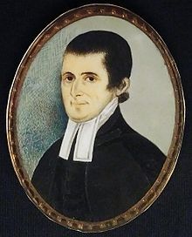](https://en.wikipedia.org/wiki/File:Gershom_Mendes_Seixas.jpg)**

**Rev. Gershom Mendes Seixas**

In 1768, Congregation Shearith Israel, the Spanish and Portuguese synagogue in New York City, appointed 23-year-old Gershom Mendes Seixas as its hazzan, or reader. Seixas was one of six children of Isaac Mendes Seixas, a Portuguese converso whose family had to flee to London after Isaac's father was accused, in 1725, of secretly continuing to practice his ancient faith.

In 1730, Isaac left London for New York, where in 1741 he married Rachel Levy, an Ashkenazic Jew. Their son Gershom was the product of this "mixed" Sephardic-Ashkenazic marriage common to the New York Jewish community in the 1700s.

New York City in the 1760s had fewer than 300 Jews, and one synagogue, Shearith Israel, which followed the ancient Sephardic minhag despite having a majority of Ashkenazic members. The congregation was a kehillah, or synagogue community, the center of Jewish life for this tightly knit group.

The community gathered at Shearith Israel to celebrate holidays and life events together: marriages, births and deaths. As hazzan of the congregation, Gershom Mendes Seixas was at the center of the community's effort to live Jewishly while immersed in the relatively tolerant atmosphere of America — a setting much less hostile than the one that drove Seixas' family, one generation earlier, from Portugal.

We note that Seixas was hazzan of Shearith Israel, not its rabbi. It was not until the mid-19th century that America attracted its first permanent ordained rabbi, that is, a religious leader and teacher trained by senior rabbis and certified as competent in Torah, Talmud and Halacha. [note that Abraham Joseph Rice (born Abraham Reiss) (c. 1800 – 1862) was the first ordained rabbi to serve in a rabbinical position in the United States. Rice was born in 1800 or 1802 at Gochsheim, near Schweinfurt, Lower Franconia].

Prior to the 1850s, ordained European rabbis would not remain in North America; they were apparently unwilling to live without learned colleagues, or to serve congregants who had, with few exceptions, fallen away from strict Orthodox practices. Seixas, as the only religious official in the congregation, functioned as spiritual leader, interpreter of religious law, supervisor of kashrut, performer of marriages and funerals and all the varied duties we now associate with ordained rabbis.

Seixas received his Jewish education primarily from his father. He was not a college graduate, but self-educated in Talmud and secular literature, including Christian texts. New York's Jewish community was simply too small to live isolated from its non-Jewish neighbors, and Seixas had many friends and associates among the city's Protestant elite.

One sign of the respect in which Seixas was held was his appointment, in 1784, as trustee of Columbia College, now Columbia University. Perhaps nothing better accounts for Seixas' esteem in the general New York community, than his actions during the American Revolution.

Despite the fact that his congregation was split on the issue, in 1775 Seixas — a strong advocate for American independence — persuaded a majority that Shearith Israel should close, rather than operate during a British occupation of New York. Just three weeks after, his wife Elkaleh had a miscarriage, and doubtless with a heavy heart at leaving his flock behind, Seixas packed the congregation's books and sacred scrolls and removed them, with his family, to his father-in-law's home in Strafford, Connecticut.

In 1780, Seixas relocated to Philadelphia to become hazzan of congregation Mickve Israel. Despite his personal abhorrence of war, in his sermons Seixas regularly called on G-d to bless the Revolution, the Congress and George Washington, the commander-in-chief of the patriot armies. He considered the American cause, with its emphasis on individual liberty, as a just war, and independence a blessing for America's Jews.

At wars end in 1784, Congregation Shearith Israel invited Seixas to resume his pulpit. At the time, Elkaleh was ill and Gershom was content in his Philadelphia post, but was ultimately persuaded to return to New York, where he served as hazzan or "minister" at Shearith Israel until his death in 1816. In 1787, when George Washington was inaugurated as the first president of the United States, Seixas was one of three clergymen who participated a sign of respect for Seixas and the role that Jews had played in the founding of the new nation, and a reflection of Washington's own ecumenical views.

Seixas devoted much of his time and prestige to encouraging charity toward the poor. Contrary to Christian doctrine, Seixas preached that riches was no sign of grace, nor poverty a sign of disgrace. Each status was a challenge from G-d: for the poor to endure and overcome hardship, and for the wealthy to grow virtuous by acts of charity.

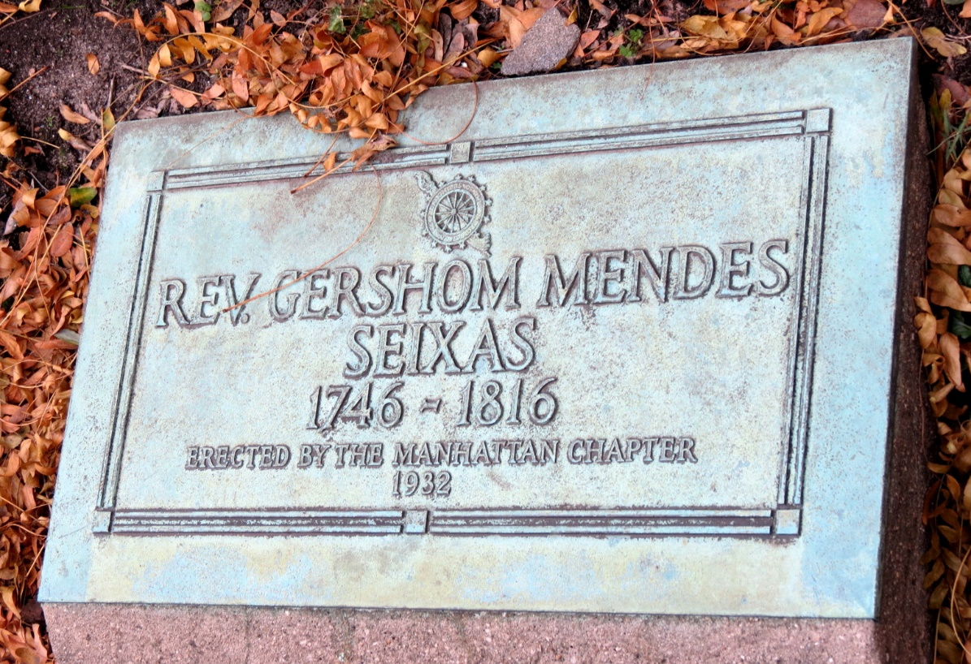

Seixas believed that the very purpose of a fortunate person's life was to help others, regardless of whether they were rewarded for their generosity. When he died, Seixas was mourned throughout New York City. The trustees of Columbia College commissioned a medal with his likeness.

His friend, Dr. Jacob de la Motta, noted that, during the last seven years of his life, "his sufferings were beyond the ken of human conception," yet Seixas served his congregation until near the very end. The first American-born hazzan of Shearith Israel, Seixas still serves as a model for the contemporary American rabbi. (Jewish Virtual Library - American Jewish Historical Society)

**Reprinted from the Parshas Shemos 5782 email of whY I Matter, the parshas sheet of the Young Israel of Midwood in Brooklyn, edited by Yedidye Hirtenfeld.**

**Shtadlanim: Rabbi Moshe Sherer (1921-1998)**

**By Jonathan Rosenblum**

\[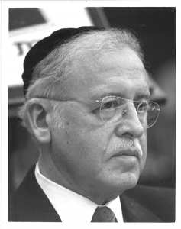](https://jewishaction.com/content/uploads/2021/11/Sherer1.png)

**Rabbi Moshe Sherer**

Mike Tress’s passion brought Agudath Israel of America into existence; his cousin Rabbi Moshe Sherer’s strategic acumen, administrative savvy, and unrivalled people skills forged Agudath Israel into a large, highly effective organization.

Under Mike, Agudah hurtled from one life-and-death crisis to another—the wartime rescue work, supplying the needs of the survivors after the war and settling them up in America and Israel, and doing the same for refugees from Hungary in 1956—at a time when the Orthodox community lacked almost any financial resources.

As soon as Rabbi Sherer cleared away the accumulated debts of over a quarter century, he set out to realize a long-term vision of building an independent Orthodoxy that would speak for itself to the public and in the halls of power.

He played a lead role in gathering Orthodox legal talent under the aegis of COLPA (Commission on Law and Public Affairs) to battle the American Jewish Congress on issues such as aid to parochial schools.

In a 1960 letter to Telshe Rosh Yeshivah Rav Mordechai Gifter, he lamented Agudah’s lack of an organ to speak to the masses. And his first concrete goal upon assuming the helm of Agudath Israel was the creation of a first-class magazine of ideas, *The Jewish Observer.*

In the mid-1970s, he spearheaded the creation of the South Brooklyn Community Organization to prevent the decline of Boro Park, as had previously happened to Crown Heights. That multi-year project required funding from the Ford Foundation, the US government, and private businesses and individuals with a stake in Boro Park. Richard Schifter, a leading housing attorney, wrote off three million dollars in fees to SBCO. (Later, as a senior State Department official, Schifter played a major role in rescuing both Iranian Jews and those from the former Soviet Union.)

[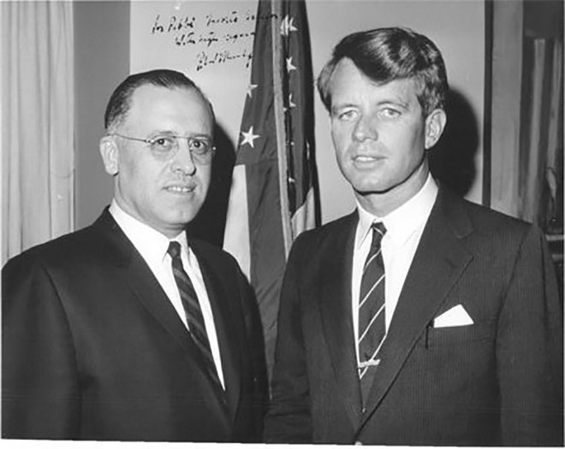](https://jewishaction.com/content/uploads/2021/11/Sherer2.jpg)

**Rabbi Moshe Sherer with Robert Kennedy, circa 1960.**

The creation of AARTS, an accrediting agency that made possible large-scale federal funding for post-high school *yeshivos,* was a nine-year project for Rabbi Sherer. It only came to fruition because at every turn the Department of Education official in charge of accreditation, Dr. John Proffitt, waived or interpreted bureaucratic requirements in favor of AARTS.

At the end of the project, Proffitt wrote Rabbi Sherer to express how much he prized his friendship and of his regard for Rabbi Sherer “as one of the small group of superior persons I have come to know.”

Rabbi Sherer cultivated a vast array of politicians, senior bureaucrats in both Albany and DC, as well as young legislative and administrative aides. Many of the latter on whom Rabbi Sherer lavished attention in their younger years went on to senior positions later in their careers.

The amount of thought he put into those relationship astounds. Before the recently widowed Hugh Carey was sworn in for his first term as governor of New York, Rabbi Sherer sent him a list of officials in Albany with children of the same ages as the Carey children, and who lived close to the governor’s mansion.

But he treated the janitor and receptionist in the building housing the Agudah offices with the same respect and concern. Every encounter with a non-religious Jew or a gentile was, in his eyes, an opportunity for *kiddush Hashem*.

He became, in time, the most respected and effective leader of American Orthodoxy. Then Vice President Al Gore Jr. put it well at an abbreviated Agudah dinner just hours after Rabbi Sherer’s passing. Eulogizing Rabbi Sherer, Gore urged his listeners not to think just of how far they had come since 1941, when Rabbi Sherer joined the Agudah, but of “how far Rabbi Sherer himself brought us.”

**Reprinted from the Winter 2021 edition of Jewish Action Magazine.**